scarpet 3-part termination argument:

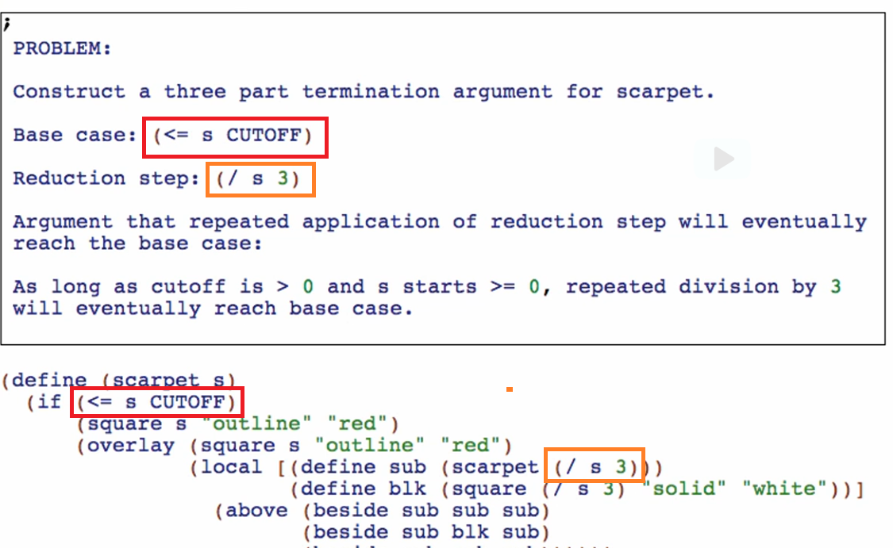

Let’s do the hailstones 3-part Termination Argument

Base case

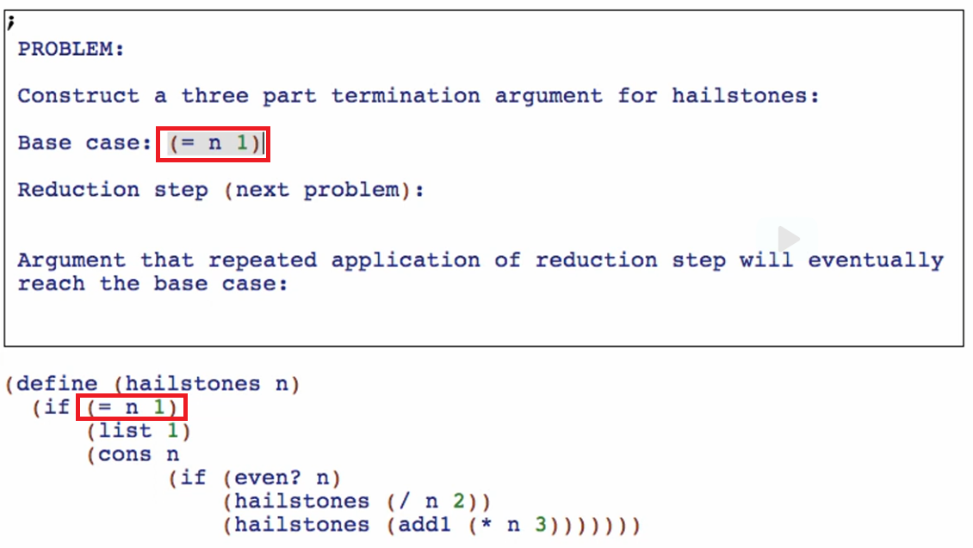

Reduction step

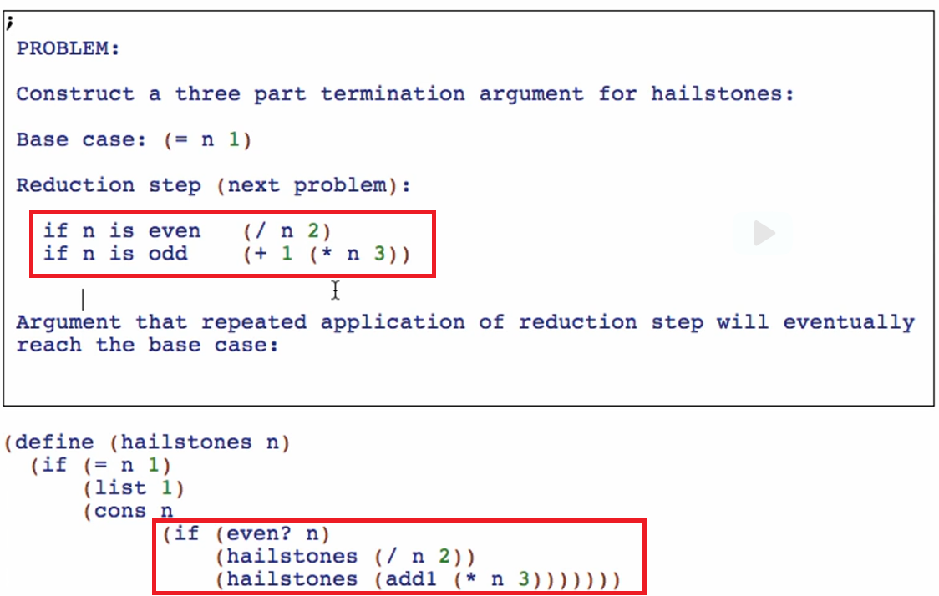

Argument that repeated application of the reduction step will eventually reach the base case:

For the even case



We can prove here that n will eventually reach 1 (our base case) since it is always dividing by 2

But for the odd case



We can see here that n is always increasing in value! Mathematicians haven’t proved this argument yet! No one has a proof yet but it is always reaching one

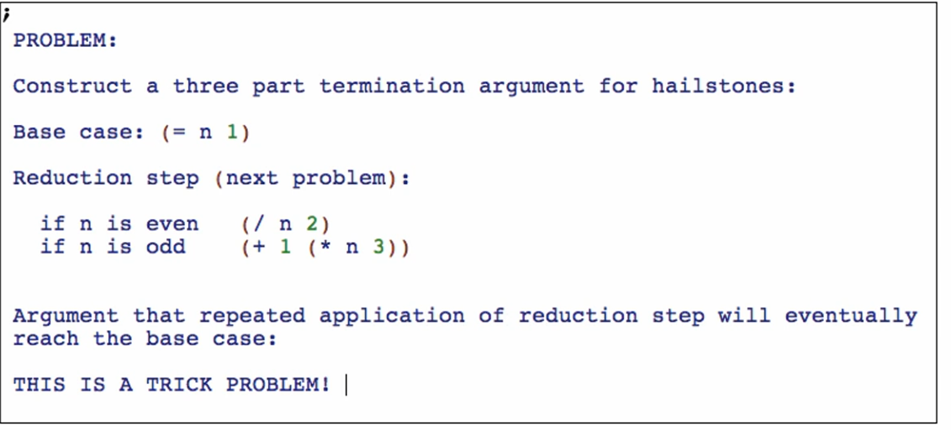

Termination arguments are NOT ALWAYS SIMPLE!

* Even simple functions have hard termination arguments and some extreme cases it’s impossible! Not yet proven by the mathematicians of the world